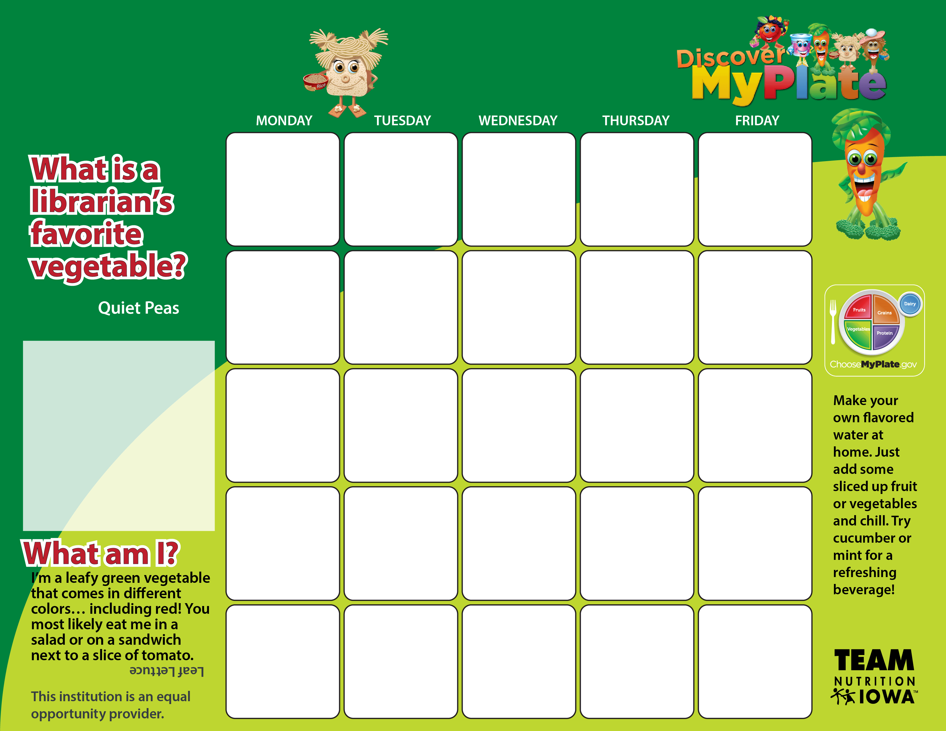

**JULY-LUNCH Sportsman, Farragut, Library**

July 23

TURKEY SUB

BAKED CHIPS  
FRESH FRUIT   
MILK

FRUIT OPTIONS: Melons,

Kiwis, Bananas, Apples,

Strawberries, Blueberries,

Peaches, Pears

We will be serving fresh, local produce this month!!!!

Aug 3

PIZZA

ICE CREAM

SALAD/DRESSING  
FRESH FRUIT   
MILK

Aug 2

WALKING TACO   
TREAT!  
FRESH FRUIT   
MILK

Aug 1

TURKEY BACON WRAP

SWEET CORN   
FRESH FRUIT   
MILK

July 31

CLUB SUB   
BAKED CHIPS   
FRESH FRUIT   
MILK

July 30

UNCRUSTABLE

GO-GURT

CARROTS/RANCH  
FRESH FRUIT   
MILK

July 27

PIZZA ROLL UPS

VEG/DIP  
FRESH FRUIT   
MILK

July 26

NACHOS WITH GROUND BEEF   
NACHO TOPPINGS!  
FRESH FRUIT

TREAT!  
MILK

July 25

POPCORN CHICKEN SALAD  
FRESH FRUIT   
MILK

July 24

CHICKEN NUGGETS   
DINNER ROLL  
CORN ON COB!!!  
FRESH FRUIT   
MILK

July 20

CHICKEN WRAP   
BAKED CHIPS   
FRESH FRUIT   
MILK

July 19

WALKING TACO   
SWEET CORN   
FRESH FRUIT   
MILK

July 18

TURKEY SUB

BAKED CHIPS

FRESH FRUIT

MILK

July 17

HAM/CHEESE CROISSANT  
VEG/DIP   
FRESH FRUIT   
MILK

July 16

CHICKEN SANDWICH

FRUIT

MILK

July 13

UNCRUSTABLE

CELERY/PB  
FRESH FRUIT   
MILK

July 12

NACHOS WITH GROUND BEEF   
FRESH FRUIT

TREAT!  
MILK

July 11

CHICKEN SANDWICH

CORN ON THE COB  
FRESH FRUIT   
MILK

July 10

HAM SANDWICH

BAKED CHIPS

VEG/DIP   
FRESH FRUIT   
MILK

July 9

PIZZA MUNCHABLE   
FRESH FRUIT   
MILK

July 6

TURKEY SANDWICH

BAKED CHIPS

FRESH FRUIT

MILK

July 5

PANCAKES

CEREAL

FRESH FRUIT

MILK

July 4

Happy 4th of July! No meals served today-See you tomorrow!

July 3

PIZZA ON GO

SALAD/RANCH

FRESH FRUIT

MILK

July 2

UNCRUSTABLE

GO-GURT

WG COOKIES

FRUIT

MILK

**SUMMER 2018**